|  |  |
| --- | --- |
|  | **Functional Specification Document (FSD)**  **ESB**  **Magma Fincorp Ltd.** |

Table of Contents

1 Document Control 2

1.1 Revision History 2

1.2 Document Approval 2

2 Introduction 3

2.1 Business Objectives 3

3 High Level Architecture 4

3.1 Document Scope 4

3.1.1 Service Interactions 5

4 Business Requirement Specification 6

4.1 Fetch QSR Report 6

4.1.1 Sequence Diagram 6

4.1.2 Design Considerations 6

4.1.3 Parameters 6

4.2 LOS De-Dupe Request 6

4.2.1 Sequence Diagram 6

4.2.2 Design Considerations 7

4.2.3 Parameters 7

4.3 LOS De-Dupe Response 7

4.3.1 Sequence Diagram 7

4.3.2 Design Considerations 7

4.3.3 Parameters 8

4.4 Fetch Existing Customer 8

4.4.1 Sequence Diagram 8

4.4.2 Design Considerations 8

4.4.3 Parameters 8

4.5 Get IMD Status 8

4.5.1 Sequence Diagram 8

4.5.2 Design Considerations 8

4.5.3 Parameters 8

4.6 PRDISBURSMENTREQUEST_SME AND HFC 8

4.6.1 Sequence Diagram 8

4.6.2 Design Considerations 8

4.6.3 Parameters 8

4.7 UPDATE DOCUMENT STATUS 8

4.7.1 Sequence Diagram 8

4.7.2 Design Considerations 8

4.7.3 Parameters 8

4.8 UPDATE FIALLOCATION 8

4.8.1 Sequence Diagram 8

4.8.2 Design Considerations 8

4.8.3 Parameters 8

4.9 UPDATEFORECLOSURECHARGES 8

4.9.1 Sequence Diagram 8

4.9.2 Design Considerations 8

4.9.3 Parameters 8

5 GETFORECLOSURECHARGES 8

5.1.1 Sequence Diagram 8

5.1.2 Design Considerations 8

5.1.3 Parameters 8

5 8

5.1 FI_Allocation

5.1.1 Sequence Diagram 8

5.1.2 Design Considerations 8

5.1.3 Parameters 8

5.2 Sub Ledger Creation

5.2.1 Sequence Diagram 8

5.2.2 Design Considerations 8

5.2.3 Parameters

5.3 Sub Ledger Creation

5.3.1 Sequence Diagram 8

5.3.2 Design Considerations 8

5.3.3 Parameters

6 Non-Functional Requirements 9

6.1 Logging and Error Handling Framework 9

6.2 ESB Header 9

7 Annexure 10

7.1 Mapping sheet 10

7.1.1 API Parameters 10

# Document Control

## Revision History

|  |  |  |  |
| --- | --- | --- | --- |
| **Version** | **Date** | **Author** | **Description** |
| 1.0 | 06/06/2019 | Rakesh Chhabria | Initial Draft |
|  |  |  |  |
|  |  |  |  |
|  |  |  |  |

## Document Approval

|  |  |  |  |  |
| --- | --- | --- | --- | --- |
| **Version** | **Date** | **Reviewer** | **Role** | **Status** |
| 1.0 |  |  |  |  |

# Introduction

## Business Objectives

The expected outcome after the implementation of the services ISAS below:

* Ability to integrate with various business end systems e.g. LOS,LMS
* Ease Business Integration

# High Level Architecture

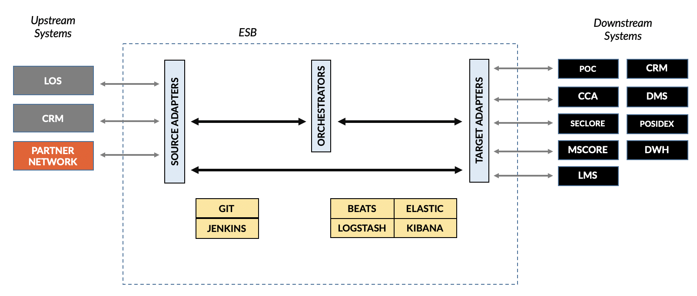

|  |  |
| --- | --- |
| **Components** | **Description** |
| LOS | Loan Originating System |
| ESB | The middleware layer to be implemented |
| GIT | Source version control management system |
| JENKINS | This will used for automated deployment process |
| Elastic Stack | This includes Beats, Logstash, Elasticsearch, Kibana for logging the data. |
| POC | Field investigation system |
| CRM | MS Dynamics Customer Relation Management system |
| CCA | Core System for LOS and LMS |
| DMS | OmniDocs - Document Management System |
| SECLORE | Digital Rights Management |
| POSIDEX | Internal De Dupe application |
| MSCORE | Business Rule Engine |
| DWH | BEAM – Data Warehousing system |
| LMS | Loan Management System |

## Document Scope

The purpose of this document is to detail out the design for all the web services exposed by the ESB layer for Magma Fincorp Ltd. It also includes all the design and implementation components for all the integration applications exposed by the ESB layer.

This document specifies the in-scope business requirements of all the applications with which the ESB layer would integrate with, for ease of business processing:

* LOS (SME/HFC)
* LMS
* CRM
* POC
* DWH
* POSIDEX
* DMS
* MSCORE
* SECLORE
* CCA

### Service Interactions

This document covers the ESB touch points for Magma Fincorp Ltd. at various end systems.

Below are the list of services that are in scope:

|  |  |  |  |
| --- | --- | --- | --- |
| **#** | **Service** | **Source** | **Destination** |
| 1 | Integration with QSR-Quick Screening Report (BRE-QSR SME, BRE Call 1-HFC, DAAS Call -1 ABF) | LOS | CRIF/Experian |
| 2 | Internal de dupe for new customer +Financial de dupe | LOS | CCA |
| 3 | Get Existing customer details on Proposal number | LOS | CCA |
| 4 | Integration with BRE /Experian (BRE Call 1 -SME, BRE Call 2 and 3- HFC, DAAS Call -2 ABF) | LOS | CRIF/Experian |
| 5 | FI Allocation | LOS | POC |
| 6 | FI response | POC | LOS |
| 7 | Get forclosure Charges + Principal outstanding(Also for tranche) | CCA | LOS |
| 8 | Update closure charges in CCA | LOS | CCA |
| 9 | Ledger Posting LOS- CCA( IMD upfront fees collection) | LOS | CCA |
| 10 | SOA generation from CCA to LOS | CCA | LOS |
| 11 | Account closure request | LOS | CCA |
| 12 | Account closure request- confirmation from CCA | CCA | LOS |
| 13 | PR approval | LOS | CCA |
| 14 | Push all customer data to CCA from LOS | LOS | CCA |
| 15 | CCA-LOS. Disbursal update from CCA+ Also URN | LOS | CCA |
| 16 | Payment release after RCU deferral or cheque number updation after handover or Cancellation request (OTC or cheque not handed over or RCU negative) | LOS | CCA |
| 17 | HRMS master data sync | LOS | HRMS |
| 18 | CCA Master synch with LOS | CCA | LOS |
| 19 | Omnidocs integration for Document upload |  | Omnidocs |
| 20 | Omnidocs integration for Document view | LOS | Omnidocs |
| 21 | IMD Posting status update from CCA-LOS | CCA | LOS |
| 22 | Pre EMI Status CCA to LOS (For OTC Breach) | CCA | LOS |
| 23 | Repayement LOS-CCA | LOS | CCA |
| 24 | Asset dedupe | LOS | CCA |
| 25 | Trade advance and RC limit | LOS | CCA |
| 26 | TBD 1 | *TBD* | *TBD* |
| 27 | TBD 2 | *TBD* | *TBD* |
| 28 | TBD 3 | *TBD* | *TBD* |

# Business Requirement Specification

## Fetch QSR Report

**Actors**: LOS, CRIF, ESB

**Description**: Application to fetch the QSR Report from CRIF application

### Sequence Diagram

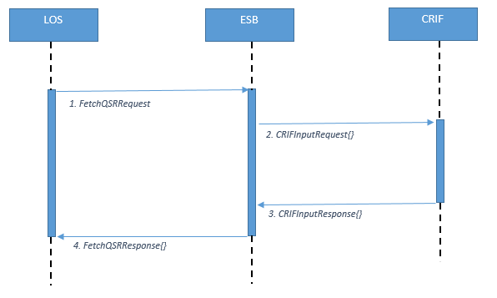

### Design Considerations

Architecture style – REST/HTTP

Method – POST

DataFormat – JSON

### Parameters

All the input and output parameters for the API has been provided in mapping sheet (refer Annexure)

## LOS De-Dupe Request

**Actors**: LOS, ESB, CCA

Description: LOS to send the data, to insert the record in CCA table for customer (Applicant / Co-Applicant) de duplication along with Reference Request ID.

### Sequence Diagraml

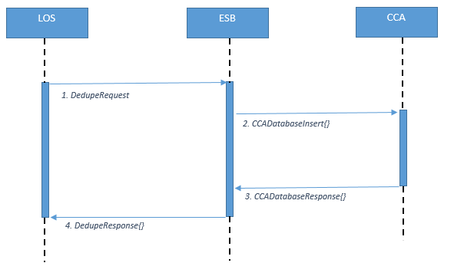

### Design Considerations

Architecture style – REST/HTTP

Method – POST

DataFormat – JSON

### Parameters

All the input and output parameters for the API has been provided in mapping sheet (refer Annexure)

## LOS De-Dupe Response

**Actors**: LOS, CCA, ESB

**Description**: LOS to send the request data with reference request id and lead no to fetch the result of the de-duplication of the relevant customer (Applicant / Co-Applicant).

### Sequence Diagram

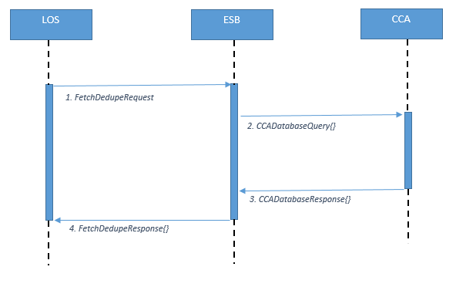

### Design Considerations

Architecture style – REST/HTTP

Method – POST

DataFormat – JSON

### Parameters

All the input and output parameters for the API has been provided in mapping sheet (refer Annexure)

## Fetch Existing Customer

**Actors**: LOS, CCA, ESB

**Description**: LOS to send request by passing either Proposal No or PAN Number to fetch the list of existing customer for the relevant data.

### Sequence Diagram

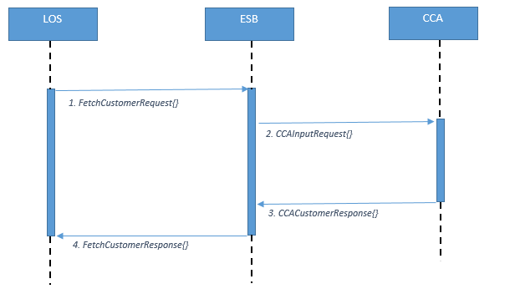

### Design Considerations

Architecture style – REST/HTTP

Method – POST

DataFormat – JSON

### Parameters

All the input and output parameters for the API has been provided in mapping sheet (refer Annexure)

## GET IMD STATUS

**Actors**: LOS, CCA, ESB

**Description**: LOS to send request in json to fetch the IMD status from CCA.

### Sequence Diagram

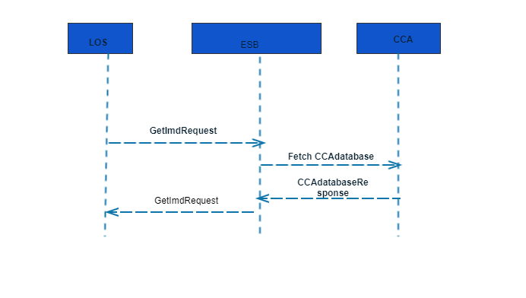

### 4.5.2 Design Considerations

Architecture style – REST/HTTP

Method – POST

DataFormat – JSON

### Parameters

All the input and output parameters for the API has been provided in mapping sheet (refer Annexure)

## PRDISBURSMENTREQUEST_SME AND HFC

**Actors**: LOS, CCA, ESB

**Description**: LOS to send PR disbursement request to CCA

### Sequence Diagram

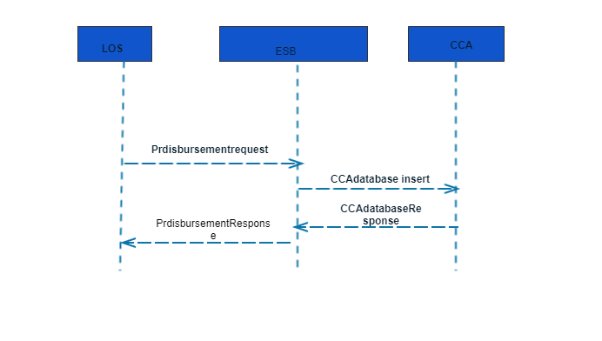

### Design Considerations

Architecture style – REST/HTTP

Method – POST

DataFormat – JSON

### Parameters

All the input and output parameters for the API has been provided in mapping sheet (refer Annexure)

## UPDATE DOCUMENT STATUS

**Actors**: LOS, CCA, ESB

**Description**: API to send document update status in CCA. Common service for SME,HFC.Depending source value in ESB header, particular table would be updated.

### Sequence Diagram

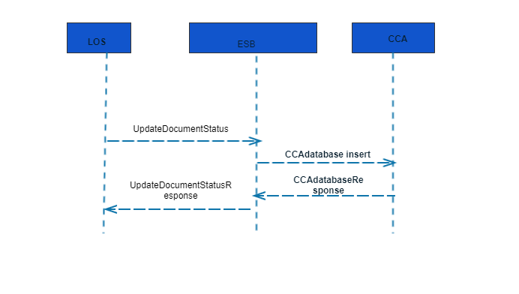

### Design Considerations

Architecture style – REST/HTTP

Method – POST

DataFormat – JSON

### Parameters

All the input and output parameters for the API has been provided in mapping sheet (refer Annexure

## UPDATE FIALLOCATION

**Actors**: LOS, CCA, ESB

**Description**: ESB run a scheduler to fetch data from POC table and on the basis of Div. Code the call SME and HFC webservice and POC table accordingly.

### Sequence Diagram

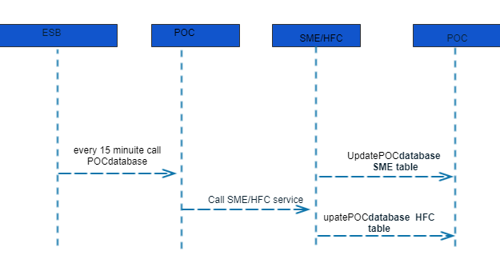

### Design Considerations

Architecture style – REST/HTTP

Method – POST

Data Format – JSON

### Parameters

All the input and output parameters for the API has been provided in mapping sheet (refer Annexure

## UPDATEFORECLOSURECHARGES

**Actors**: LOS, CCA, ESB

**Description**: LOS to send request to Web service to Update foreclosure charges to CCA

### Sequence Diagram

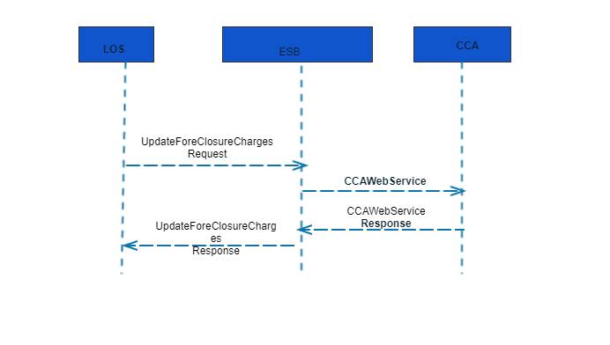

### Design Considerations

Architecture style – REST/HTTP

Method – POST

Data Format – JSON

### Parameters

All the input and output parameters for the API has been provided in mapping sheet (refer Annexure

# GETFORECLOSURECHARGES

**Actors**: LOS, CCA, ESB

**Description**: LOS to send request to Web service to fetch foreclosure charges from CCA

### Sequence Diagram

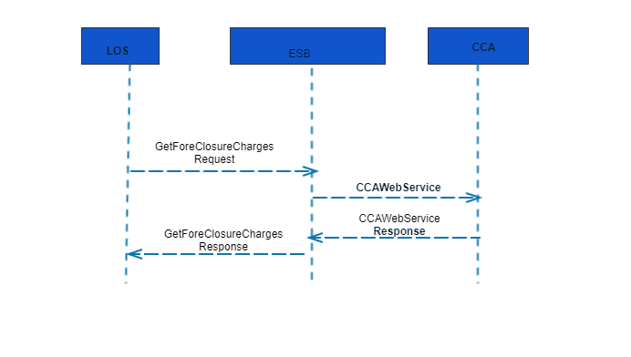

### Design Considerations

Architecture style – REST/HTTP

Method – POST

Data Format – JSON

### Parameters

All the input and output parameters for the API has been provided in mapping sheet (refer Annexure

**5.1 FI_ALLOCATION**

**Actors**: LOS, CCA, ESB

**Description**: LOS to send request to POC for FI creation

### Sequence Diagram

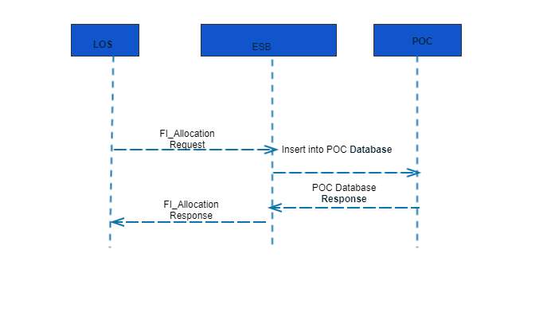

### Design Considerations

Architecture style – REST/HTTP

Method – POST

Data Format – JSON

### Parameters

All the input and output parameters for the API has been provided in mapping sheet (refer Annexure

## SUBLEDGERCREATION

**Actors**: LOS, CCA, ESB

**Description**: LOS to send request to enquiry no to CCA after FTR for subledger creation

### Sequence Diagram

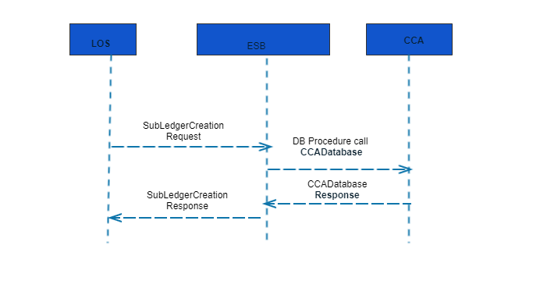

### Design Considerations

Architecture style – REST/HTTP

Method – POST

Data Format – JSON

### Parameters

All the input and output parameters for the API has been provided in mapping sheet (refer Annexure

# Non-Functional Requirements

This section captures any Non-Functional Requirements for the project.

## Logging and Error Handling Framework

All logging and Error handling are done as part of the ELK framework. The standard logger and exception design time library that is part of every process and the template will be used to write a log message or exception onto the ELK framework.

The key requirements of the logging framework are:

1. Ability to efficiently search through different application logs
2. Ability to monitor and manage applications
3. Monitor and manage applications and components with graphical view that has historical data

## ESB Header

All the input and output ESB Message Header parameters for the API has been provided in mapping sheet (refer Annexure)

# Annexure

## Mapping sheet

All the input / output parameters, ESB Headers for the API's mentioned in the annexure attachment

### API Parameters

The detailed list of the input and output parameter for all the integration systems (Source, ESB and Target) for all the APIs that are in scope for Phase 1 is captured in ESB Mapping Sheet shared across. (ESB_Mapping_Sheet.xlsx)